EMPLOYEE MANAGEMENT SYSTEM

# CREATION OF TABLE:

## Supervisor:

create table supervisor(

Id int not null unique, Name varchar(30)

); CREATE TABLE

## Department:

create table Department(

Dept_No int not null unique, Dept_Name varchar(30)

); CREATE TABLE

## Projects:

create table Projects(

Project_code int not null unique, Project_Name varchar(30)

); CREATE TABLE

## Employee:

create table Employee(

Emp_no int not null unique, Emp_Name varchar(30), Gender varchar(10), Designation varchar(30),

PAN_NO varchar(30) not null unique, DOB date,

Date_of_joining date,

Basic_pay int, Skill varchar(100)

); CREATE TABLE

# CREATION OF RELATIONAL TABLE:

## Department-Employee:

create table rt_de(

Dept_no int, Emp_no int,

Primary key(Emp_no), constraint fk_emp foreign key(Emp_no)

references employee(Emp_no), constraint fk_dep

foreign key(Dept_no)

references department(Dept_no)

); CREATE TABLE

## Department-Supervisor:

create table rt_ds(

Dept_no int, Id int,

Primary key(Dept_no), constraint fk_dep foreign key(Dept_no)

references department(Dept_no), constraint fk_sup

foreign key(ID) references Supervisor(ID)

); CREATE TABLE

## Employee-Supervisor:

create table supervise(

Emp_no int, ID int,

Primary key(Emp_no), constraint fk_emp foreign key(Emp_no)

references employee(Emp_no), constraint fk_sup

foreign key(ID) references Supervisor(ID)

); CREATE TABLE

## Employee-Project:

create table worktime(

Project_code int, Emp_no int, Intime date, Outtime date,

primary key(Project_code), constraint fk_pro

foreign key(Project_code) references projects(Project_code), constraint fk_wrk

foreign key(Emp_no) references employee(Emp_no)

);

CREATE TABLE

## Department-Project:

create table rt_dp(

Dept_no int, Project_code int,

primary key(Project_code), constraint fk_dep

foreign key(Dept_no)

references department(Dept_no), constraint fk_pro

foreign key(Project_code) references projects(Project_code)

); CREATE TABLE

# INSERTION OF DATA IN TABLE:

## Department:

insert into department values(101,'HR'),(102,'Design'),(103,'Package'),(104,'Networking'),(105,'Production'),(106,'S ecurity'),(108,'Coding');

INSERT 0 7

select * from department;

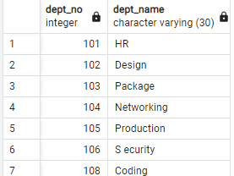

## Employee:

insert into employee values(1,'Ratish','Male','Developer','QWERT1234Y','1999-05-03','2021-04-05',65000,'Vibing'),(2,'Karthikeyan','Male','HR','ERTYU3456V','2000-03-02','2022-06-05',75000,'Creativity'),

(3,'Thirumurugan','Male','Design','ERERT4546V','2000-01-02','2020-04-23',55000,'Creativity'),

(4,'Arun','Male','Cyber','RTGFT6746V','2001-02-04','2021-06-21',75000,'content_CREATOR'),

(5,'Ajay','Male','Coding','RQWCT6746V','2001-05-04','2021-06-22',85000,'Entertainer'),

(6,'Navas','Male','Coding','QWECT4567E','2001-04-21','2021-09-21',78000,'Creativity'),

(7,'Kabileshwaran','Male','Coding','ZXCVB4567E','2000-05-22','2021-10-22',85000,'supervisor');

INSERT 0 7

test=# select * from employee;

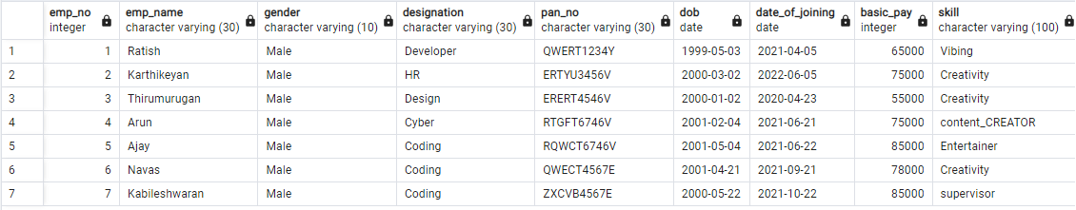

## Projects:

insert into projects values(501,'Cloud Computing'),(502,'Criminology'),(503,'DBMS'),(504,'AI'),(505,'Robotics'),(506,'Drone');

INSERT 0 6

select * from projects;

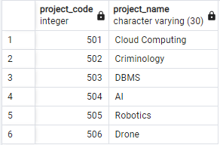

## Supervisor:

insert into supervisor values(1001,'Arun'),(1002,'Navas'),(1003,'Kabileshwaran'),(1004,'Ajay');INSERT 0 4

select * from supervisor;

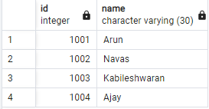

**RELATIONAL TABLE:**

## Department-Employee:

insert into rt_de values(102,1),(102,3),(108,7),(101,2);

INSERT 0 4

select * from rt_de;

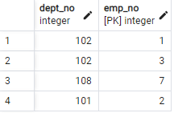

## Department-Supervisor:

insert into rt_ds values(101,1001),(102,1002),(103,1003),(104,1003);

INSERT 0 4

select * from rt_ds;

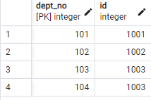

## Worktime:

insert into worktime values(501,1,'9:15','10:15'),(503,2,'10:15','12:00');

INSERT 0 2

select * from worktime;

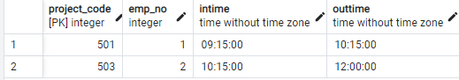

## Department-Projects:

insert into rt_dp values(106,501),(108,502),(106,503);

INSERT 0 3

select * from rt_dp;

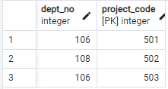

## Supervise:

insert into supervise values(1,1001),(2,1001),(3,1002),(4,1002),(5,1003),(6,1004),(7,1004);

INSERT 0 7

select * from supervise;

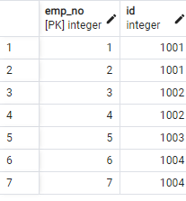

# QUERIES:

## Add an record in projects table:

insert into projects values(507,'UI');

INSERT 0 1

select * from projects;

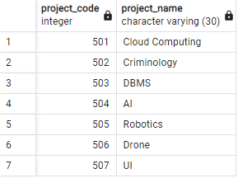

1. ***Update Salary=85000 in Employee table where Name=’Ajay’:*** update employee set basic_pay=85000 where emp_name='Ajay'; UPDATE 1

Select * from employee;

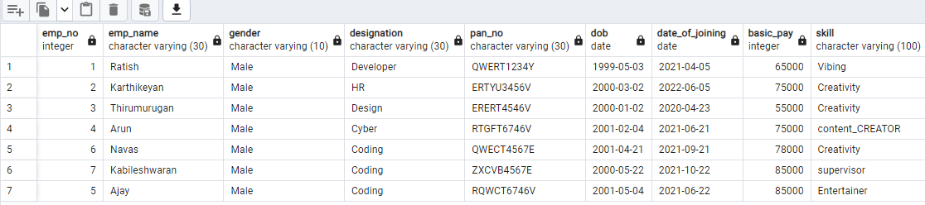

## Delete an record in Projects table:

delete from projects where project_code=507; DELETE 1

Select * from projects;

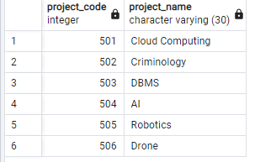

## Add a column Address in Supervisor table:

alter table supervisor add column address varchar(30); ALTER TABLE

Select * from supervisor;

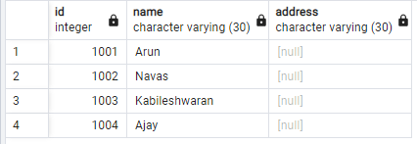

## Delete column Address in Supervisor table:

alter table supervisor drop column address; ALTER TABLE

Select * from Supervisor;

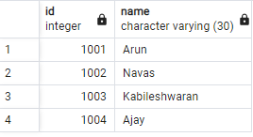

## Write a query to find count of male employees in the Employee table:

select COUNT(*) from employee where gender='Male';

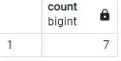

## 7)Write a query to find the employee whose Salary is between 70000 and 100000:

select emp_name from employee where basic_pay between 70000 and 100000;

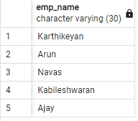

## 8)Write a query to display Employee name in upper case:

select UPPER(emp_name) from employee;

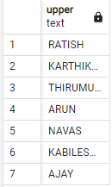

## 9)Write a query to display Employee whose age is equal to 23:

select emp_name from employee where extract(year from age(current_date,DOB))=23;

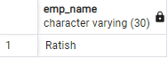

## 10)Write a query to find the employees working in the department ‘HR’:

select emp_name from employee where designation='HR';

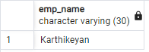

## 11)Write a query to retrieve first four characters of Employee from Employee table:

select substring(emp_name,1,4) as name from employee;

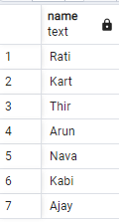

## 12)Write a query to find Department which has linked with a Project in it:

select dept_name from department where dept_no in (select dept_no from rt_dp);

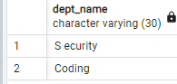

## 13)Write a query to find employees for the supervisor named ‘Arun’:

select emp_name from employee where emp_no in(select emp_no from supervise where id=(select id from supervisor where name='Arun'));

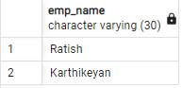

## 14)Write a query to find all female Employees in Employee table:

select emp_name from employee where gender='Female';

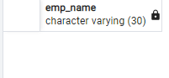

## 15)Write a query to find all Employees whose name starts with ‘K’:

select emp_name from employee where emp_name like 'K%';

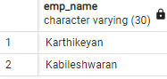

## 16)Create a new table which consist of the data of the Supervisor table:

create table newtable as select * from supervisor;

SELECT 4

select * from newtable;

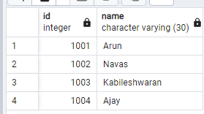

## 17)Write a query to find which Employee is getting high paid salary:

select emp_name from employee where basic_pay=(select MAX(basic_pay) from employee);

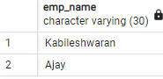

## 18)Write a query to retrieve Emp name and Salary together as Name with Salary from Employee table:

select CONCAT(emp_name,' ',basic_pay) as Name_with_Salary from employee;

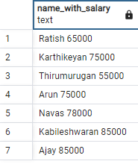

## 19)Write a query to find the age of all employees in Employee table:

select emp_name,extract(year from age(current_date,DOB))*12 + extract(month from age(current_date,DOB)) as age_in_month from employee;

## C:\Users\student\Pictures\Screenshots\q38.png

## 20)Delete all records from newtable:

truncate table newtable; TRUNCATE TABLE